Practical-7
Practical Title: PHP Form Processing with Server-Side Validation and CSV/JSON File Storage
Problem Definition: Process submitted registration/contact form data using PHP. Validate and sanitize inputs on the server side and store records in CSV or JSON file format. Display success/error messages.
A.Theory:
1.Is the form submitted using POST?
Answer: Yes.
2. Are inputs validated and sanitized server side?
Answer: Yes.
3. Is file writing handled safely?
Answer: Yes.
4. Are success and error responses displayed clearly?
Answer: Yes.

B.Implementation/ Output/Result
In this practical, the concepts of PHP form handling and file handling were used by me to build the login page. The form was submitted using the POST method, which sends the data in the body of the HTTP request instead of showing it in the URL, so the password is not exposed in the address bar. On the server, the submitted values were read from the $_POST superglobal array, and $_SERVER["REQUEST_METHOD"] was used to check that the form had actually been submitted before any processing started. The input was sanitized with trim() and validated on the server with preg_match() and regular expressions, because client-side checks can be bypassed and server-side validation is the one that protects the data.
For file handling, the valid data was stored in a CSV file. The file was opened in append mode ("a") using fopen(), so new records were added at the end without erasing the old ones, and the file was created automatically if it did not exist. The flock() function was used to lock the file while writing, so two users submitting at the same time could not corrupt it. Each record was written as a comma-separated row using fputcsv(), which also handles special characters correctly, and the file was closed with fclose() to release the lock and save the data. The is_dir() and mkdir() functions were used to create the data folder when needed, and the password was converted with password_hash() before saving, so the file never contains the real password.

C.Evidence Of Work(Screenshots):
1)Login Page:
All Fields are Valid and clicked Login button:
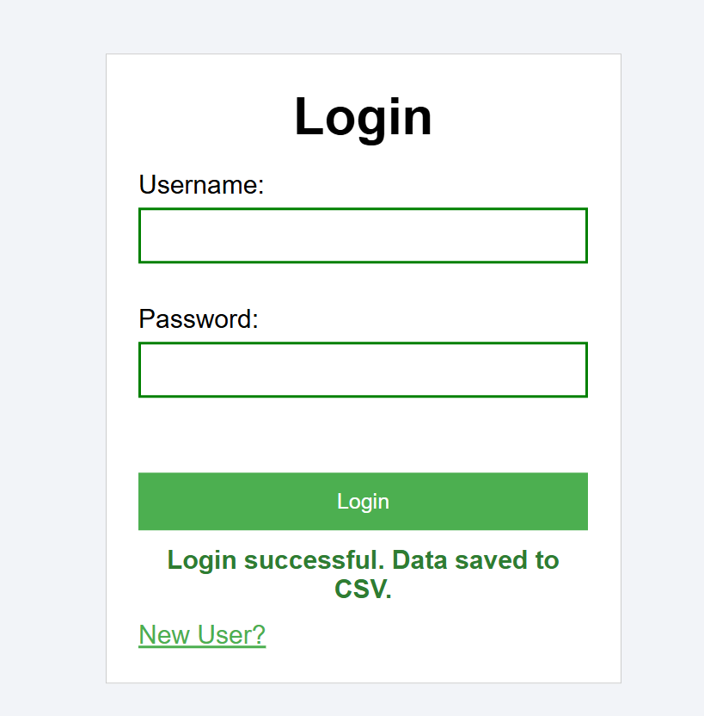

Invalid Fields:
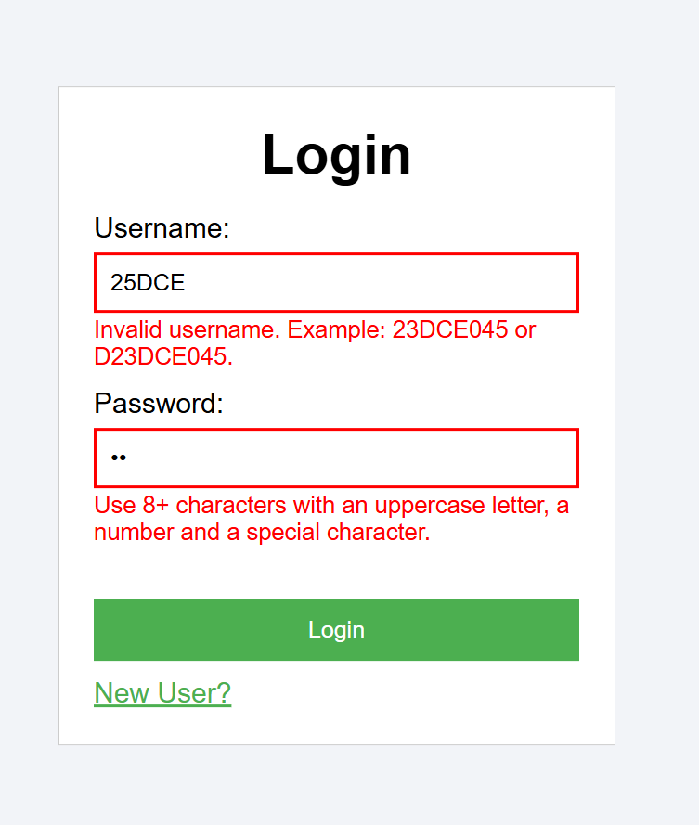

D. GitHub Repository Link: https://github.com/HimeshMale/Student-Hub-Portal.git

E. Challenge Faced:
Challenge was to learn how php works and what is the way to validate data in it. Syntax was way different then we actually sees in common languages like js,c.Also the file handling part was tougher than expected.

F. Learning Outcomes:
Through this practical, I learned how to process user-submitted form data securely on the server side by enforcing input sanitization and validation for POST requests, managing error and success notifications, and safely persisting structured records into CSV and JSON files using file-locking techniques to prevent data corruption.
Faculty Remarks:

